Lab #1 Exercises

Due Date: Sunday October 3 at midnight. You will record your answers in the Lab #1 Exercises ‘Quiz’ on our course Blackboard page.
Use this document to work out the activities/exercises and record your answers for quick reference while taking the ‘Quiz’.
When you are ready, navigate to the Lab Assignments link -> open the Lab #1 Exercises folder -> and open the Lab #1 Exercises quiz link located at the bottom.
This Lab #1 is worth 72 points.

*Important Note: Don’t wait until the last minute to attempt these lab exercises. If you have questions, email me sooner rather than later. Late submissions will not be accepted unless you have coordinated an extension with me before the due date of October 3.

Week One: Introduction to Geology/Plate Tectonics/Seafloor Spreading

1. Refer to the geologic time scale provided in your textbook (Figure 1.6 on page 8). Record the Eon, Era, Period, and Epoch we currently live in. (4 pts)
Eon: Phanerozoic Era: Cenozoic Period: Quaternary Epoch: Holocene

2. Geologists view Earth as a system, and the Earth system as the interplay between open systems or “spheres” in the environment. Using the information from section 1.4 of your textbook as your guide, name the spheres of the Earth system. (8 pts; 2 pts each)

Hydrosphere
Atmosphere
Geosphere
Biosphere

3. Complete two concept sketches of plate tectonic boundaries from the list given below. Make sure they are neat, legible, and colorful! Color helps to define what you are looking at. Labels must be well written, clear, and detailed. Labels should explain what is happening at all locations in the sketch.

Here is an example of a well-done sketch:
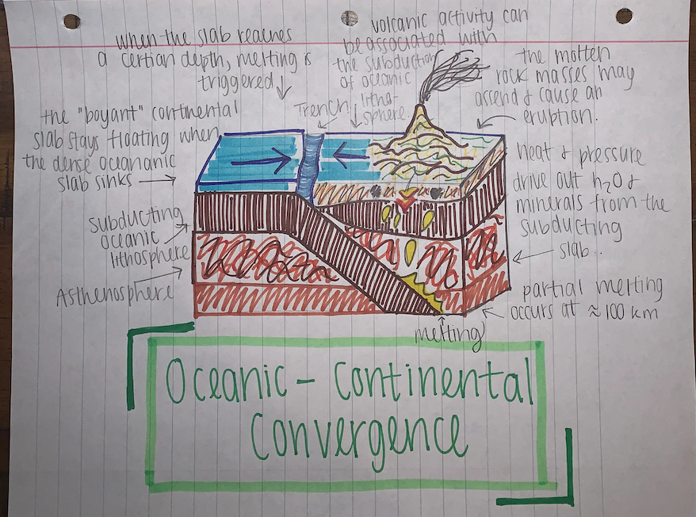

Types of plate tectonic boundaries:
- Divergent boundary at a mid-ocean ridge.
- Divergent boundary when a continent splits apart. (You would need to show the stages here in a series of sketches.)
- Convergent boundary between a continental and an oceanic plate.
- Convergent boundary between two continental plates.
- Convergent boundary between two oceanic plates.
- Transform boundary on a continent.

Here's what you will need to do:
- Read Chapter 2 carefully, paying special attention to the figures of the plate boundaries and the descriptions of what happens at each boundary type.
- Sketch 2 of the 6 boundaries listed above. Label the sketches in full sentences or coherent phrases, describing what is happening at the boundary and identifying important features.
- Photograph each sketch and be ready to upload them as attachments on the Lab #1 quiz in Blackboard.

Each sketch is worth 10 points (total 20 pts).
Weeks Two: Minerals/Introduction to Rocks/Igneous Rocks/Volcanoes

4. The Earth system is full of cycles: the water cycle, the carbon cycle, the life cycle, and, related to this course, the rock cycle. The rock cycle is a conceptual model of how matter and energy flow through Earth’s systems over time. The rock cycle can be seen in SmartFigure 1.23 on p.23 of your textbook. Using that figure as your guide, complete the missing information in the rock cycle diagram provided below. (9 pts)

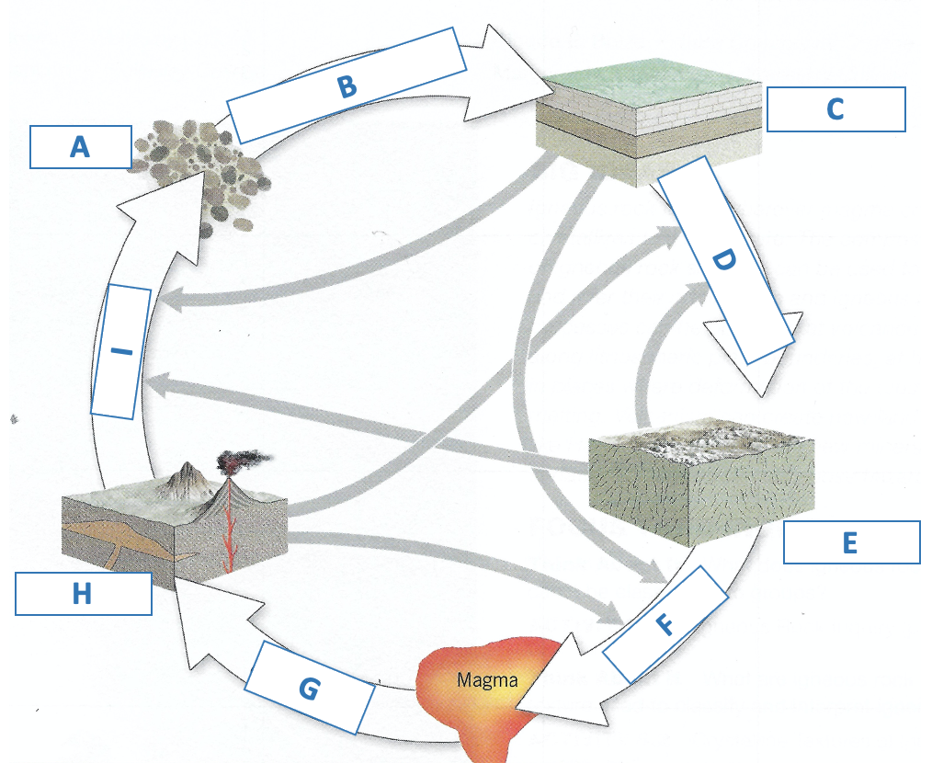

A:Sediment F: Melting
B:Lithification G: Crystallization
C:Sedimentary Rock H:Igneous Rock
D:Metamorphism I:Weathering
E:Metamorphic Rock

5. Now that you have some familiarity with the rock cycle, let’s look at processes and rock properties with more specificity. Identify which rock type is characterized by each of the processes and rock properties listed in the table. (Hint: the only property associated with multiple rock types is Crystalline; all other processes and properties can only be attributed to one rock type.) (10 pts)

Processes and Rock Properties | Igneous | Sedimentary | Metamorphic
Lithification of sediment |  | x
Intense heating (but not melting) |  |  | x
Crystals precipitate from water |  | x
Solidification of magma/lava | x
Melting of rock | x
Compaction of sediment |  | x
Folding of rock |  |  | x
Crystalline | x
Foliated |  |  | x
Common fossils |  | x

6. Access the Virtual Mineral and Rock Kit in the left menu on our course Blackboard page and find the section for Minerals. Navigate to Module One in our course Blackboard page and open the Lab #1 folder. There you will find the link for Mineral Identification - Instructional Information. Watch the video and read through the information provided to help you identify the mineral samples in your virtual kit.

The video titled “Identifying Minerals” can also provide some useful information for this task. This video is located in Week 3 in the “Review Material” folder.

The following minerals are in your kit (in no particular order): Biotite, Calcite, Fluorite, Galena, Gypsum, Muscovite, Potassium Feldspar, Pyrite, and Quartz.

Fill out the table below with the physical property characteristics for each mineral: color/clarity, luster, streak color, hardness, and cleavage. Identify the correcr mineral name for Minerals A – I in your virtual kit. I have done Mineral Sample A for you. (8 pts)

Mineral Sample | Color / Clarity | Luster  (Metallic / Nonmetallic) | Streak Color | Hardness | Cleavage | Name of Mineral
A | Translucent / white | Nonmetallic | None | > 5.5 | Conchoidal  Fracture | Quartz
B | Opaque/ Brass yellow | Metallic | Black | 6 to 6.5 | Conchoidal fracture | Pyrite
C | Opaque/Lead gray | Metallic | None | 2.5–2.75 | Cubic | Galena
D | Translucent/White | Nonmetallic | White | 3 | Cubic | Calcite
E | Transparent/Colorless | Nonmetallic | White | 4 | Basal | Fluorite
F | Opaque/Pink | Nonmetallic | White | 6 to 6.5 | Prismatic | Potassium Feldspar
G | Transparent/Colorless | Nonmetallic | White | 2 | Basal | Gypsum
H | Opaque/Black | Metallic | White to gray | 2.5 to 3 | Basal | Biotite
I | Translucent/Tint Green | Nonmetallic | White | 2.5 to 3 | Basal | Muscovite

7. Access the Virtual Mineral and Rock Kit in the left menu on our course Blackboard page and find the section for Igneous Rocks. Navigate to Module One in our course Blackboard page and open the Lab #1 folder. There you will find the link for Igneous Rock Identification - Instructional Information. Watch the video and read through the information provided to help you identify the igneous rock samples in your virtual kit.

The following igneous rocks are in your kit: Basalt, Gabbro, Granite, Obsidian, Rhyolite, and Scoria.

Fill out the table below with the chemical and physical property characteristics you observe for each igneous rock, then identify the correct rock name for Rocks A - F in your virtual kit. I have done Rock Sample A for you. (5 pts)

Rock Sample | Mafic Color Index | Minerals Present | Texture | Rock Name
A | Mafic | Pyroxene; Plagioclase Feldspar | Aphanitic (fine grained) | Basalt
B | Felsic | Potassium Feldspar, Quartz, Sodium Plagioclase, Biotite, Hornblende | Aphanitic (Fine-grained) | Rhyolite
C | Felsic | feldspar, quartz, mica, and amphibole minerals | Phaneritic (coarse) | Granite
D | Mafic | basaltic or andesitic in composition/approximately 50% silica and 10% calcium oxide with lesser contents of potash and soda | Vesicular | Scoria
E | Felsic | composition similar to rhyolite and granite/mainly of SiO2 (silicon dioxide) | Glassy | Obsidian
F | Mafic | pyroxene, plagioclase, and minor amounts of amphibole and olivine | Phaneritic (coarse) | Gabbro

8. Volcanic landforms come in a wide variety of shapes and sizes, and each volcano has a unique eruptive history. Composite volcanoes (also known as Stratovolcanoes), Shield volcanoes, Cinder Cones, and Lava Domes are the most common styles of volcano.
Magma viscosity (“resistance to flow”) is the primary factor affecting whether volcanoes erupt “violently” (as in the 1980 eruption of Mt. Helens) or “gently” (as in eruptions of Kilauea on the island of Hawaii):
- High-viscosity magmas generally produce explosive eruptions.
- Low-viscosity magmas generally produce nonexplosive eruptions.
Magma viscosity is affected by magma composition, temperature, water content, and volatile content:
- Magmas containing more silica are more viscous. Therefore, magmas with a felsic (rhyolitic) composition are relatively viscous due to their high proportions of silica, while magmas with a mafic (basaltic) composition have lower proportions of silica and are less viscous.
- Magma temperature is another factor contributing to viscosity. Magma flows more easily and is less viscous at higher temperatures. Additionally, because the materials in mafic magmas melt at a higher temperature than those in felsic magmas, mafic magmas are less viscous.
- Magmas with high water content lowers viscosity.
- The ease with which volatiles, such as dissolved water, can escape from the magma contributes to the difference in eruption styles. Low-viscosity magmas allow gases to escape with relative ease, and therefore contain low amounts of gases. High-viscosity magmas do not allow gases to easily escape, and therefore contain higher amounts of gases.
Using Chapter 5 of your textbook and the details provided above, identify the volcano type for each example. Also provide one location example for that volcano type. (8 pts)
- Volcano A: Silica and gas content are both high (viscosity is greatest). This silica rich magma is cooler and is so viscous that it hardly flows at all.
  - Lava Domes

- Volcano B: Silica, gas content, and eruption temperature are all moderate (viscosity is moderate – allowing for both periods of explosiveness as well as readily flowing magma).
  - Shield volcanoes

- Volcano C: Silica and gas content are both relatively low (viscosity is low, allowing for magma to easily flow far). This is the least explosive of the volcano types.
  - Cinder Cones

- Volcano D: Silica and gas content are moderately high at eruption onset, then wain as the eruption progresses (this yields a field of pyroclastics surrounding the volcano crater, and a lava field flowing away from the crater).
  - Composite volcanoes

